Week 4 Gate 4 Assessment Report
Participant: Premchand Chellisseril Pramod
Date: 27-06-2026

SELENIDE
Test: Check availability of project
STATUS: PASSED
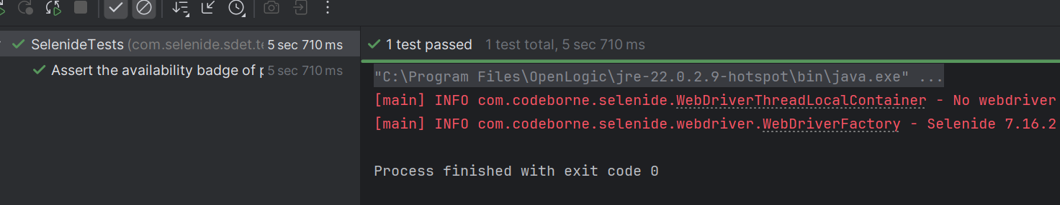

Commands to run:
mvn test

API Contract
Test: Consumer creates pact
STATUS: PASSED
RESULT: pact created in target/pacts
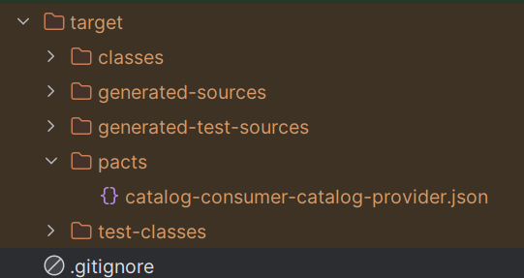

Test: Provider verifies pact
STATUS PASSED
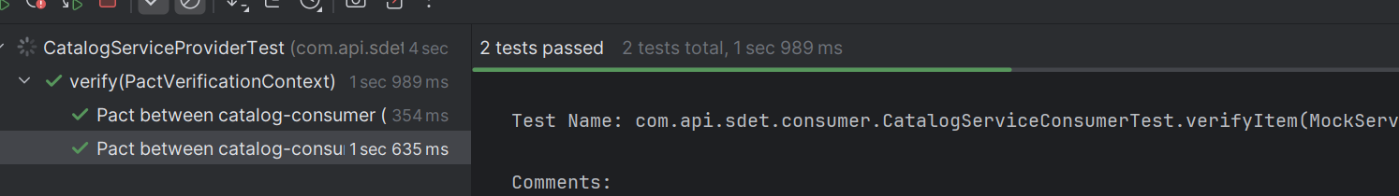

Consumer.yml runs:
- Consumer tests
- Show generated pact files
- Publish pact to PactFlow

Provider.yml runs:
- Run provider verification
- Can I deploy
- Record provider deployment to production
